Antioch Youth Internship Program - Summer 2021
SUMMER 2021
CALL FOR MENTORS
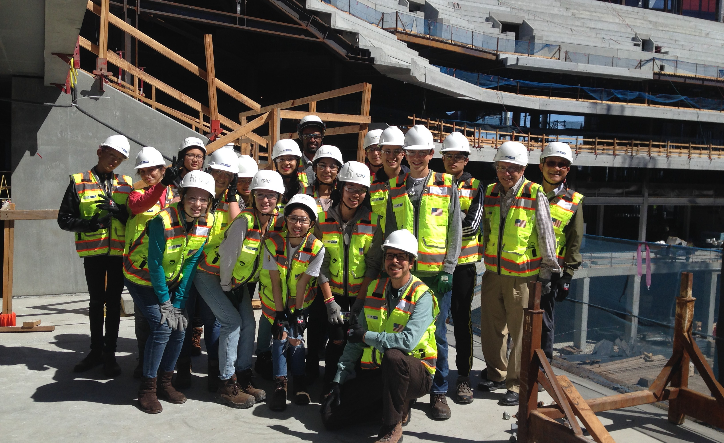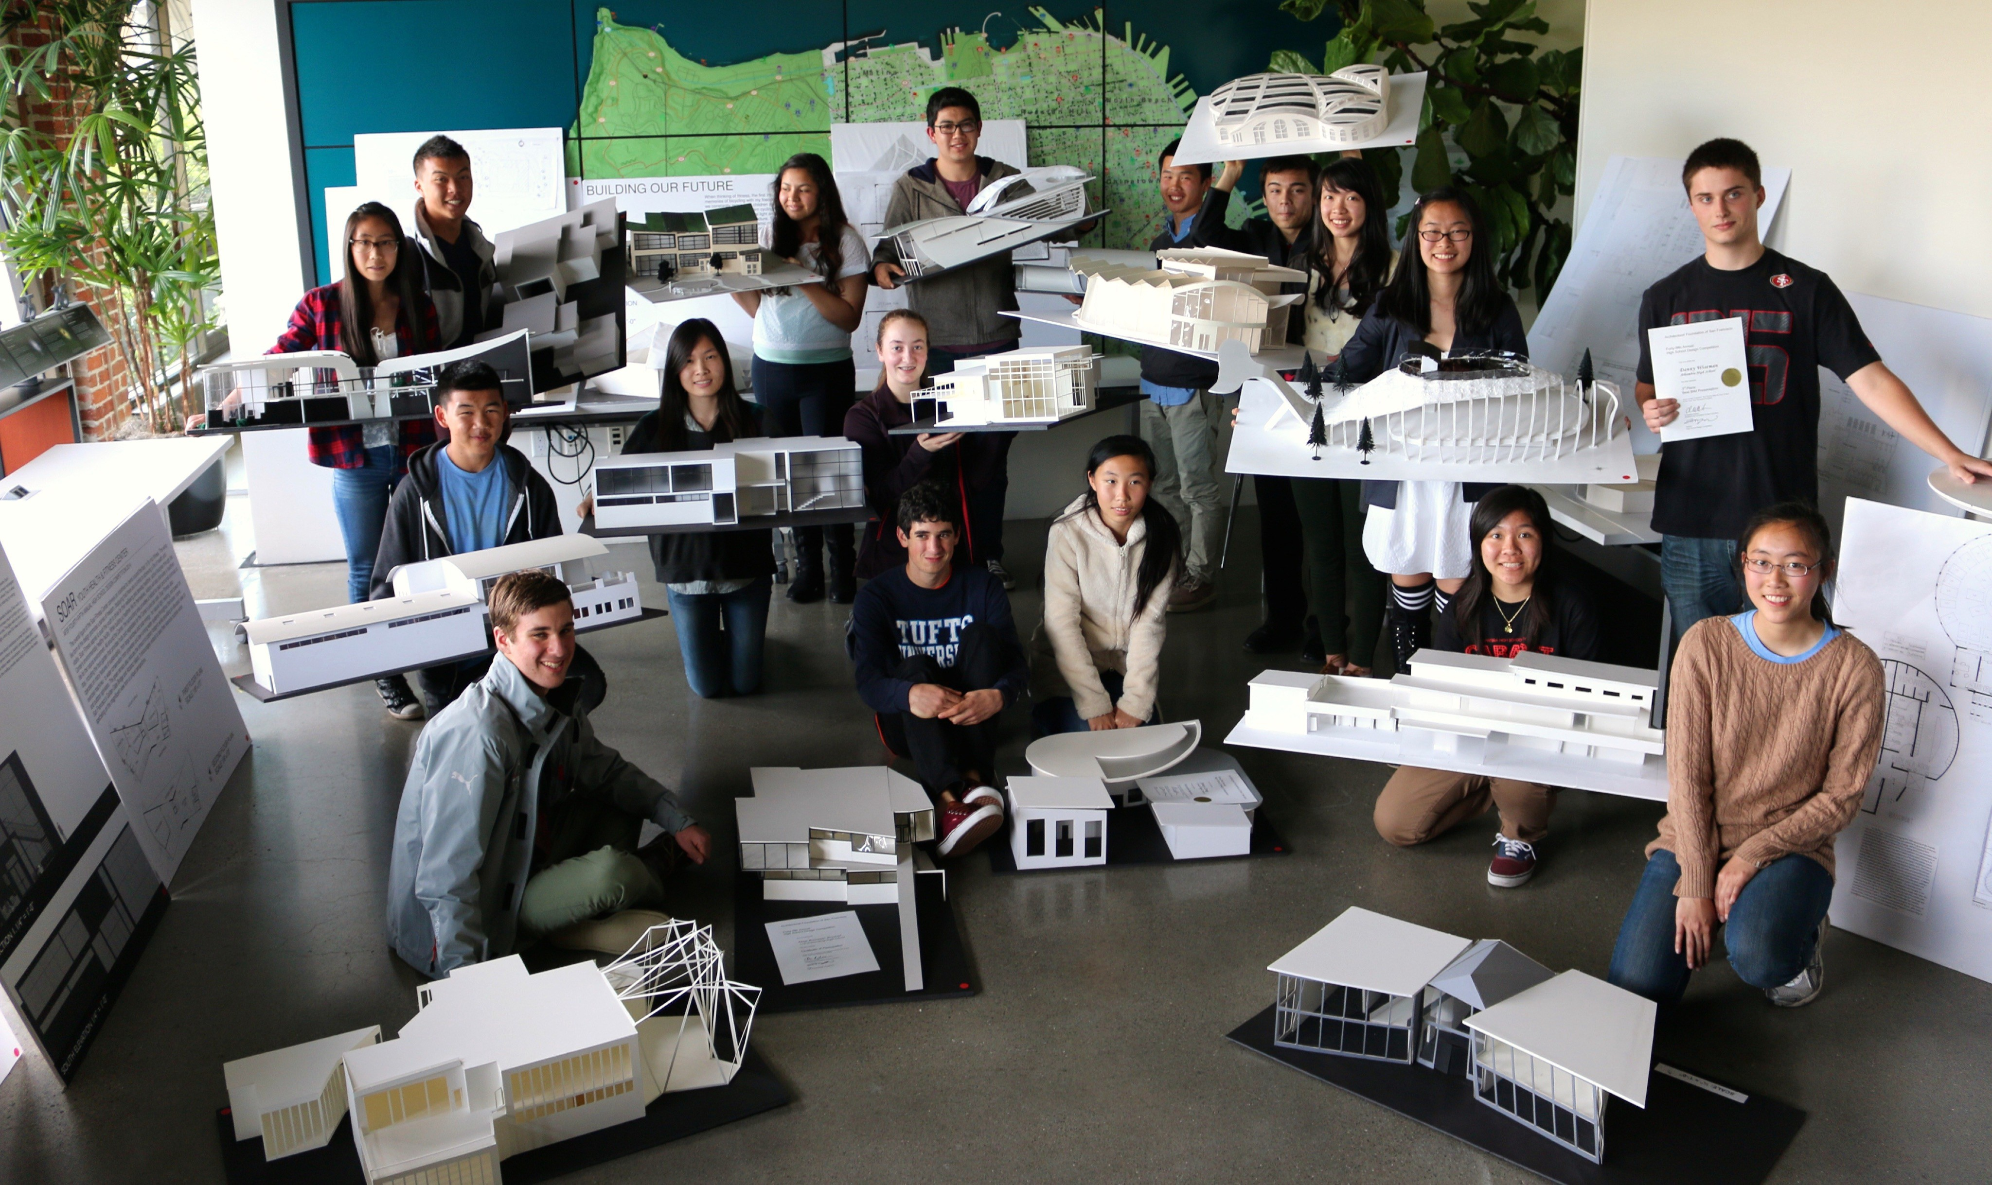
About The Program
In our partnership with the City of Antioch, youth from underserved Antioch neighborhoods enroll in paid internships to gain workplace experience exploring design for the first time in professional settings, helping them visualize and orient their own future goals. Interns will be placed from July 26 - August 27 and will have once-a-week mentoring.

These mentors assist the interns in understanding the complexity of construction in the 21st century, and the wide range of issues connected with urban development.

Interns have an opportunity to develop their own design skills and to create a portfolio of work that they can use for college applications and career opportunities. In this unique program, interns will be able to learn drawing techniques, 3D modeling, photography, video, animation and work with a range of computer aided design tools including SketchUp and the Autodesk family of modeling software.

Become a Mentor
The Architectural Foundation of San Francisco, in cooperation with the City of Antioch and AIA East Bay Chapter, is asking you to help ensure equity and inclusion of access to high quality and enriching summer educational opportunities for youth in need for 5 weeks - from July 26 - August 27
In-depth interactions with a professional can have a tremendous impact on the trajectory of a young, aspiring designer. Volunteer mentors with the Architectural Foundation of San Francisco offer a critical window through which a teenager glimpses a potential future and visualizes him or herself in it. Through 1-on-1 mentoring, participants gain a deep and broad perspective on what the professional world is truly like, and some insights on how to get there.

To serve as a Mentor, please go to https://www.afsf.org/get-involved/
or contact alan@afsf.org

